Web Application Firewall SSL Certificates with ORM Stack

Contents
1. Introduction 3
2. Workflow diagram to deploy the stack 3
3. Create stack for WAF SSL Certificates 4
4. Plan the Job 6
5. Apply the Job 7
6. Verify in the Console 8

Introduction

SSL certificates are used to establish secure, encrypted connections between clients (such as web browsers) and web applications. When a client accesses a web application protected by a WAF, the SSL certificate ensures that the communication is encrypted, preventing unauthorized interception and tampering.

Workflow diagram to deploy the stack

Below diagram shows how the Terraform Artifact are applied in the OCI. While creating a ORM stack, using terraform deliverables Init, Plan and Apply is the flow to provision the resource in the OCI. We can have the deliverables in any of below.

- GitLab/GitHub Repo
- Bitbucket
- Can be in folder/.zip in the local disk
- Object Storage Bucket
- Can be in compartment
- Oracle provided Template



Create stack for WAF SSL Certificates

Go to OCI Console Developer Services Resource Manager Stacks select the compartment Create Stack

My Configuration Folder Browse Select the “certificate” folder that contains the terraform Upload

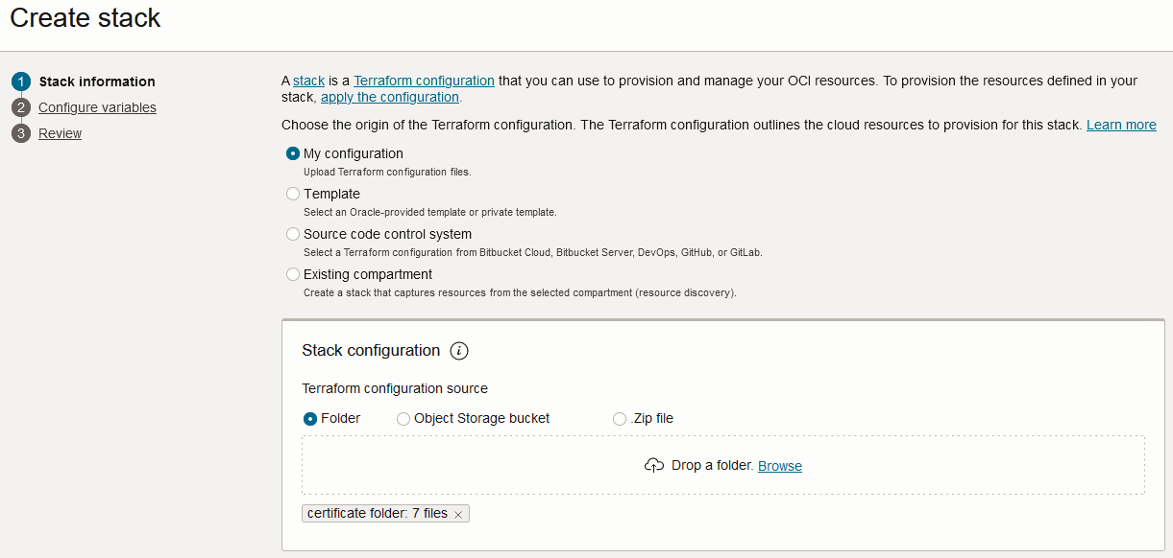

Select the parameters as per the below screens,
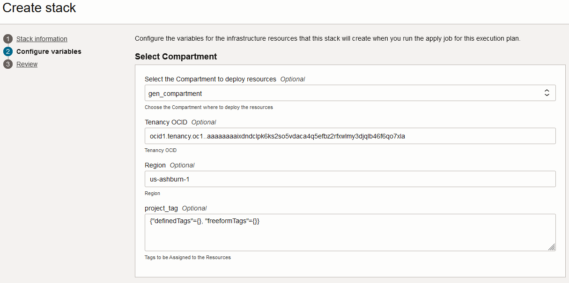
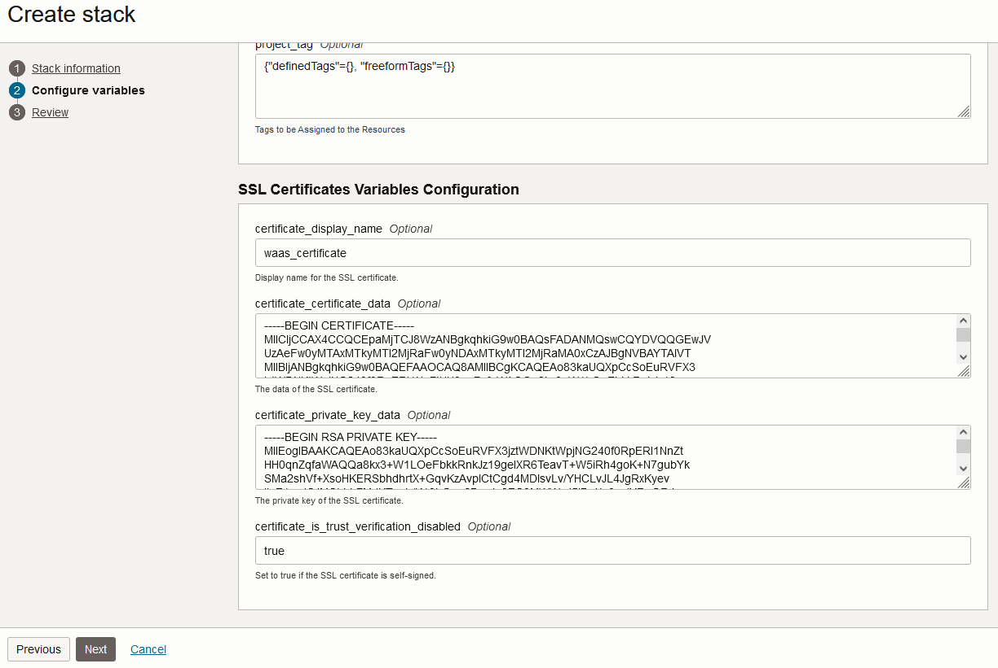
Click “Next”

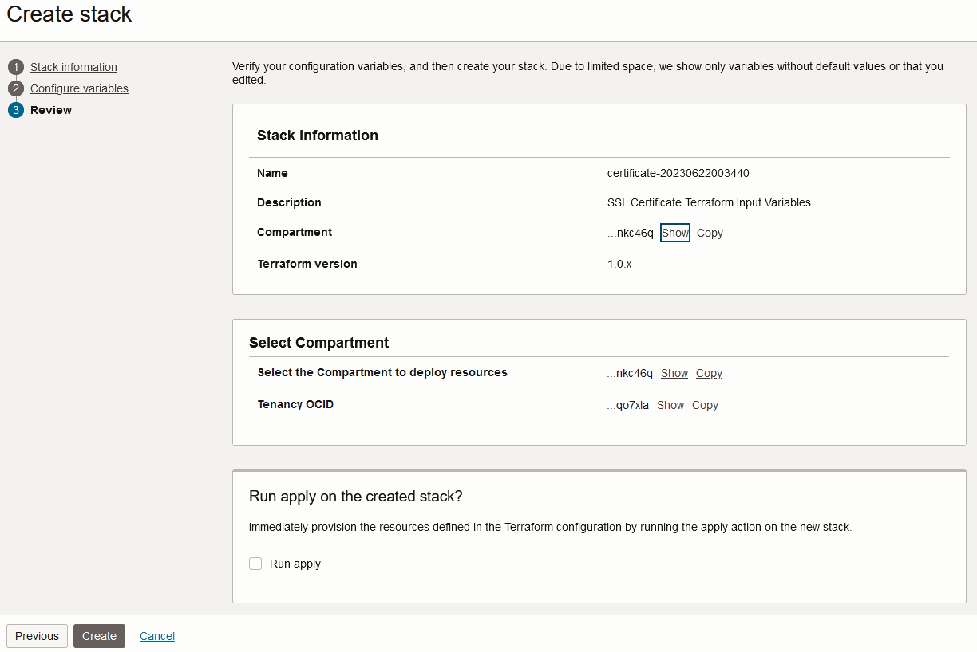
Click “Create”

Plan the Job

Click the “Plan”
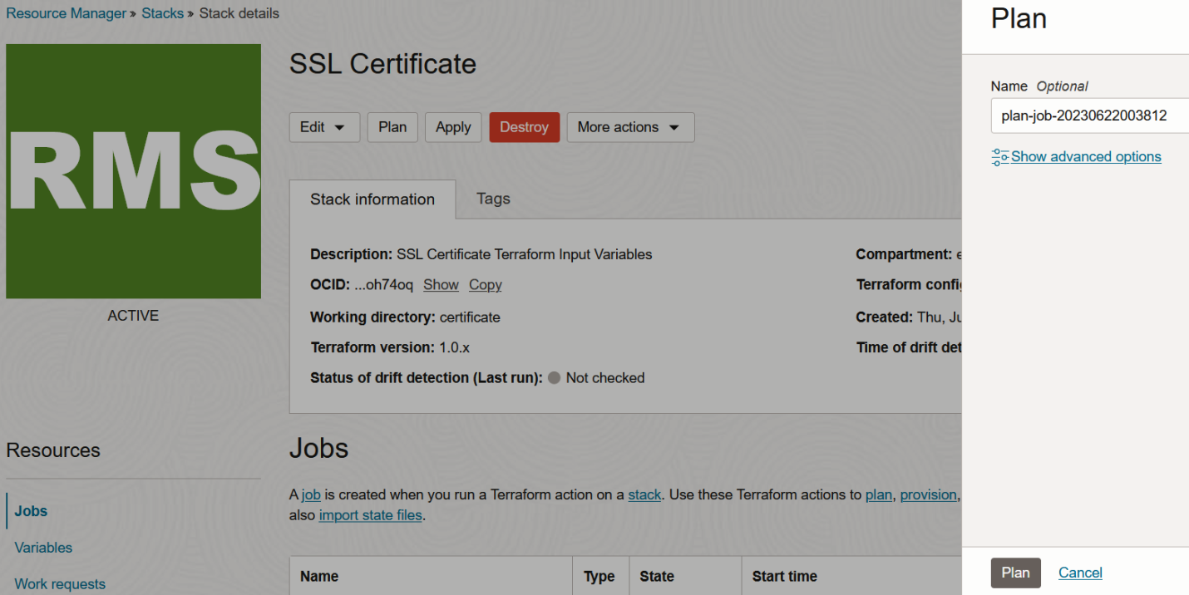

Verify the Plan is successful.

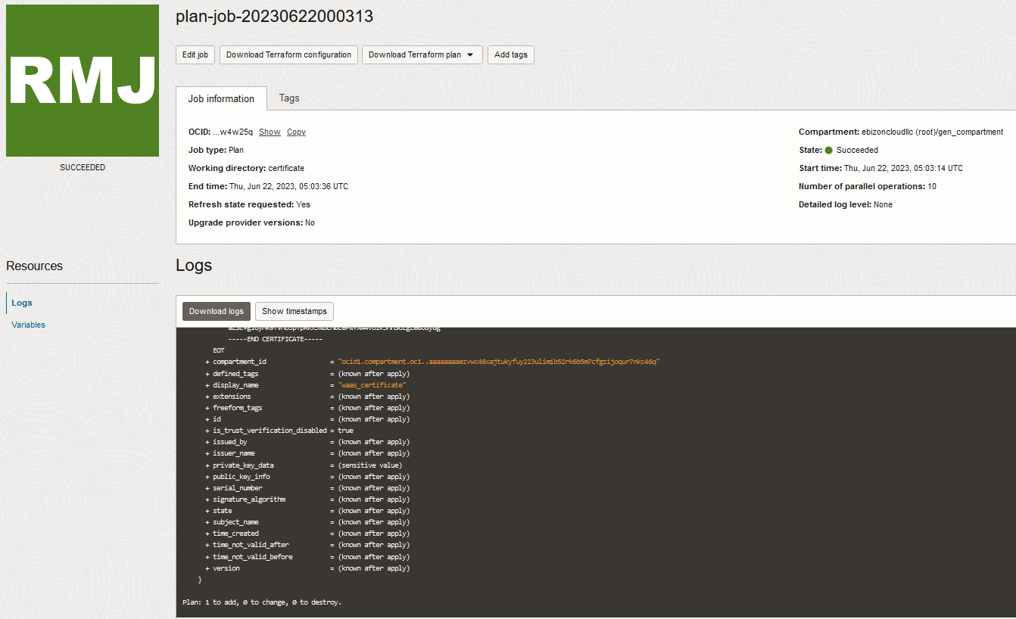

Apply the Job

Once the “plan” is success, now click “Apply”

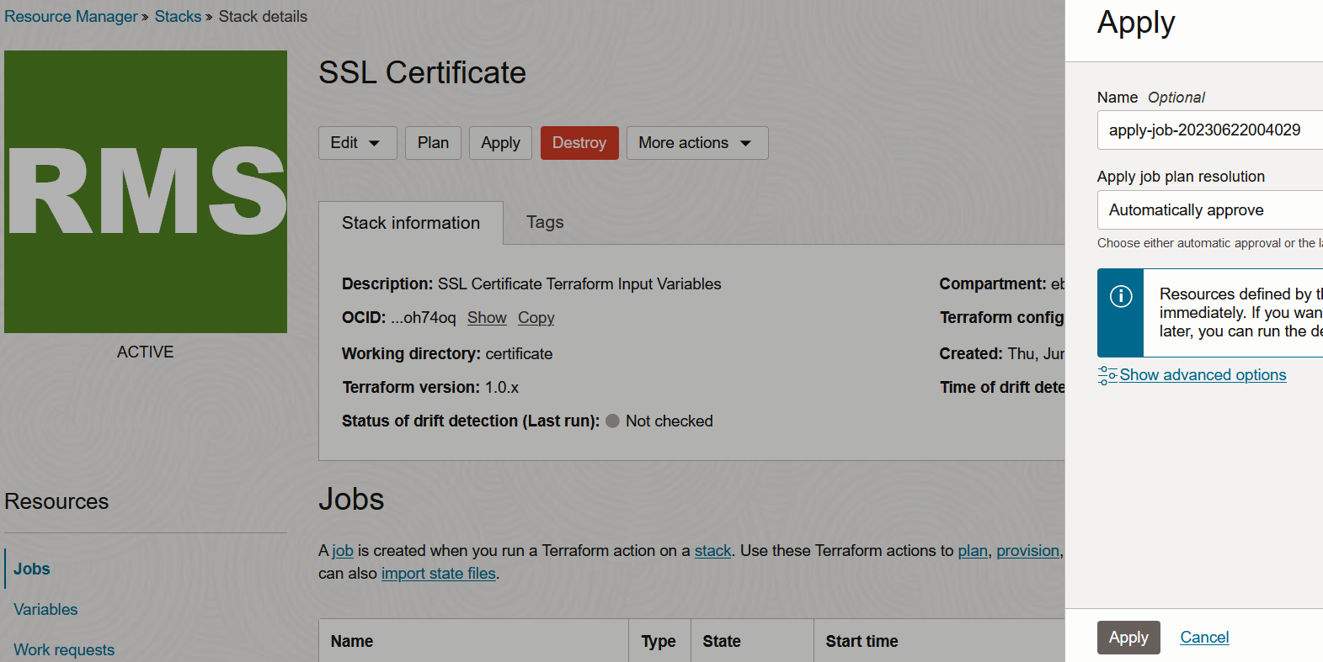

Verify the Apply is successful.

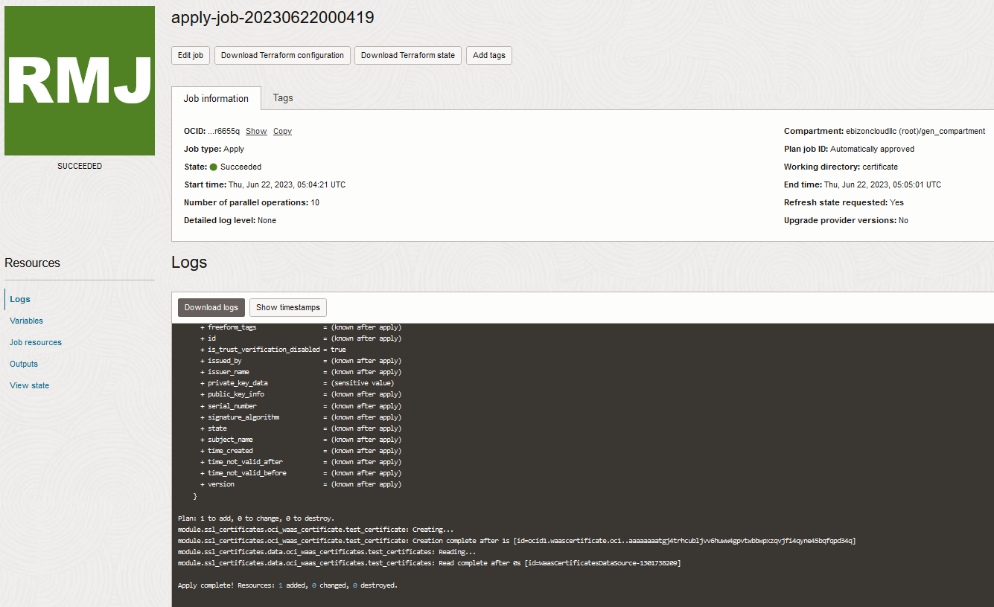

Verify in the Console

Go to OCI Console Web application firewall OCI Edge policy resources Certificates

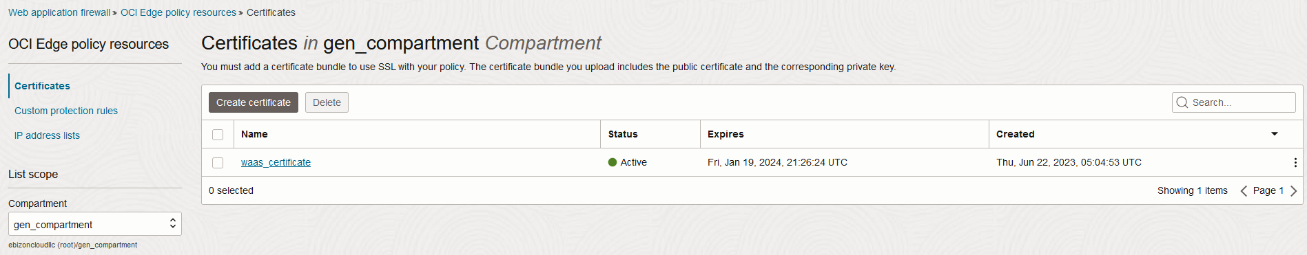

Web application firewall OCI Edge policy resources Certificates Certificate details

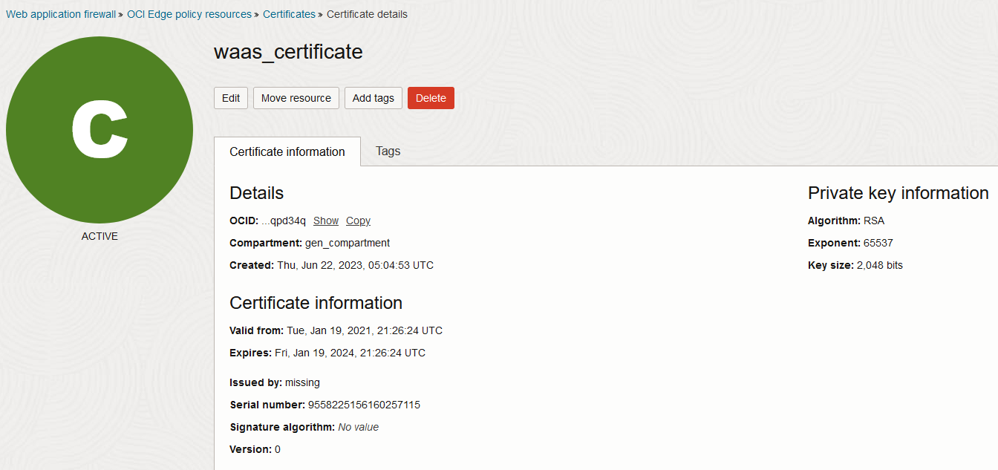

# END #

